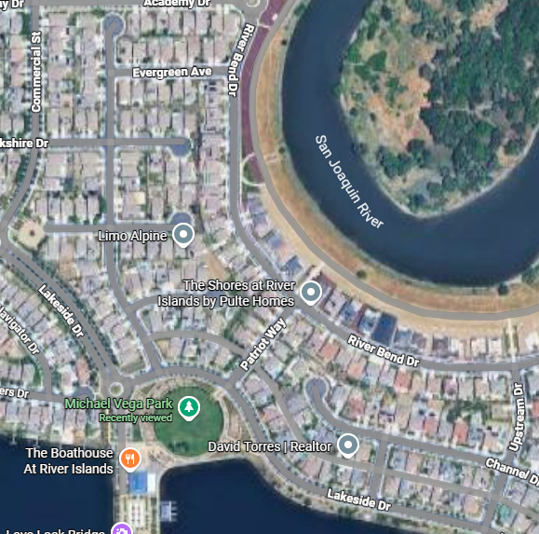
Last night LID’s emergency line started receiving calls around 8:30pm because of a disruption in power near Berkshire Ct. LID’s Emergency crew was dispatched and was able to isolate the outage to an area around Lakeside, Commercial, Academy, Riverbend, & Upstream. Around 11:22pm Crews identified a fault/trip in and inground switch near the Boathouse on Lakeside. After troubleshooting the issue, crews were able to divert power and restore power to this area around 1:00am.

