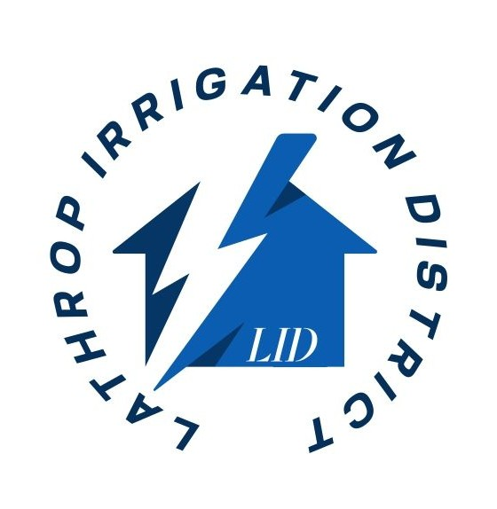
LATHROP IRRIGATION DISTRICT
JOB ANNOUNCEMENT
Part-Time Customer Service Representative (Electric Utility)

Location:
Lathrop, California
Job Type:
Part-Time
Salary Range:
$18.00 – $22.00 per hour
Application Deadline:
March 31, 2026
Position Overview
Lathrop Irrigation District is seeking a reliable and customer-focused individual to serve as a Part-Time Customer Service Representative. This position is responsible for assisting utility customers with billing inquiries, service requests, and general account support. The ideal candidate will demonstrate strong communication skills, professionalism, and the ability to work effectively with the public.
Essential Duties and Responsibilities
- Respond to customer inquiries in person, by phone, and via email
- Assist customers with account setup, billing questions, and payment processing
- Provide information regarding electric utility services, policies, and procedures
- Handle service requests, including starting, stopping, or transferring service
- Maintain accurate customer records and documentation
- Perform general administrative and clerical duties as assigned
Minimum Qualifications
- High school diploma or equivalent
- One (1) year of customer service experience (utility experience preferred but not required)
- Basic computer skills, including familiarity with Microsoft Office and data entry systems
- Strong verbal and written communication skills
- Ability to handle difficult situations with professionalism and tact
Work Schedule
This is a part-time position. Work hours may vary and may include weekdays during regular business hours. Flexibility is preferred.
Selection Process
Applications will be reviewed based on qualifications. The most qualified candidates may be invited to participate in an interview process. Final selection will be based on merit, qualifications, and organizational needs.
Equal Employment Opportunity
Lathrop Irrigation District is an Equal Opportunity Employer and does not discriminate on the basis of race, color, religion, sex, gender identity, sexual orientation, marital status, national origin, ancestry, age, disability, medical condition, genetic information, or any other status protected by law.
ADA Accommodation
In accordance with the Americans with Disabilities Act (ADA), reasonable accommodations will be provided upon request to qualified individuals with disabilities throughout the recruitment process. Please contact info@lathropirrigation.com to request accommodation.

How to Apply
Interested applicants must submit a completed application and any required materials to:
lathropirrigation.com or email resume to info@lathropirrigation.com
For questions regarding this recruitment, please contact:
LID Office / 209-888-4799 / info@lathropirrigation.com

