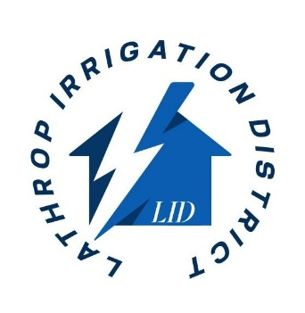

Notice: Future Power Disruption

Dear Valued Customer,

We are writing to inform you of a future power disruption that will affect your area. PG&E has scheduled federal mandated maintenance on the Schulte Switching Station-Kasson-Manteca 115kv Line to function test LID’s Junction Switches. This will require an interruption to LID Stewart Tract Switching Station and LID Substation that will result in a temporary interruption of power supply to the River Islands Community.

**Scheduled Date and Time:** 5/31/2025 6:00am-5:00pm (0600-1700)

**Reason for Disruption:** PG&E is doing federal mandated testing to the functionality of the Junction Switches along its 115kv Line. LID’s Stewart Tract Switching station is connected to the 115kv line through these Junction Switches and PG&E has informed us they will be shutting down the power feed to the LID Stewart Tract Switching station to perform the adequate testing. This testing may or may not take the entire block of time depending on if there is additional maintenance to do on these Junction Switches.

**Expected Duration:** Estimated @ 11 hours.

**Precautionary Measures:**

* **Backup Power:** Consider alternative power sources, solar energy, or backup batteries or generators, if necessary, especially for medical equipment or sensitive devices. (LID will not be providing any of this equipment)
* **Protect Electronics:** To prevent damage, unplug sensitive electronics and appliances during the outage. (LID will not be responsible for any electronics or appliances damaged due to the outage)
* **Stay Informed:** Monitor our website www.lathropirrigation.com and LID staff will send out text alerts before and after work is completed.
* **Sign up to receive Text alerts for major outages-just text "alerts" to 833-222-2154.**

## (All data fees will apply)

We apologize for any inconvenience this may cause and appreciate your understanding as we work with PG&E to safely test the above-mentioned Junction Switches.

If you have any questions or concerns, please don't hesitate to contact our customer service team at 209-888-4799 or via email at info@lathropirrigation.com

Thank you for your cooperation.

Sincerely,

Erik Jones- Lathrop Irrigation District General Manager