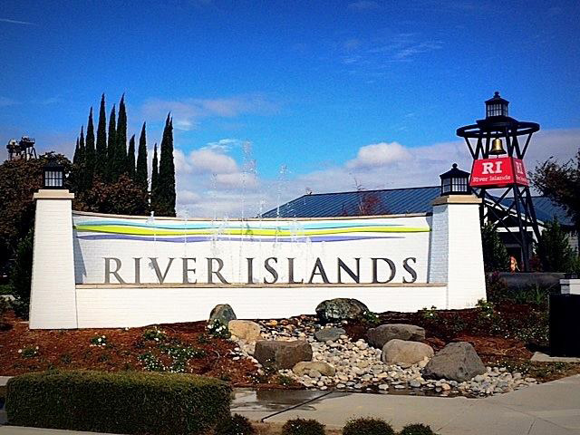

LATHROP IRRIGATION DISTRICT
2023
WILDFIRE MITIGATION PLAN

1. Introduction

Recent wildfires in the State of California have reached epic levels- homes, property, and lives have been destroyed as a result of wildfires burning during unprecedented weather events.
As a result, legislation has been enacted requiring every electric utility to prepare a wildfire mitigation plan (WMP).
SB 901 amended Public Utilities Code (PUC) section 8387. Section 8387 generally requires every publicly owned utility to construct, maintain, and operate its electrical facilities to minimize the risk of wildfire posed by those facilities. As amended by SB 901 section 8387 more specifically requires every publicly owned utility to prepare and present a WMP to its governing body by January 1, 2020, and annually thereafter. As further required by Assembly Bill (AB) 1054 enacted in 2019, the WMP shall be submitted to the California Wildfire Safety Advisory Board for review and advisory opinion by July 1, 2020. At least once every three years the submittal must be a comprehensive revision of the WMP.

The WMP must include vegetation management (VM) programs, inspection and maintenance programs, protocols for deactivating automatic reclosers and for de- energizing power lines in severe weather conditions. The plans are required to identify priority customers, such as first responders and local agencies, health care providers, water and telecommunication facilities, groups that assist children, elderly, mobility impaired and other vulnerable populations, and include communication programs for those customers. The plans need to describe how service will be restored after a wildfire and include processes for: (i) measuring the performance of the plan measures, (ii) identifying and correcting any deficiencies in the plan and; (iii) auditing implementation of the plan.
This document outlines LID’s activities in accordance with these requirements.

Lathrop Irrigation District
The Lathrop Irrigation District is an irrigation district formed pursuant to Division Il (Commencing at Section 20500) of the California Water Code supplying electrical service to residents of a 5000-acre development in the Lathrop area known as River Islands. Currently, the infrastructure is built out to only a portion of the service territory. The surrounding terrain is, for the most part, void of extensive forest or vegetation and consists of urban housing, low grasses and a few shrubs.
Within the LID service area, LID has approximately 1.1 miles of overhead transmission and approximately 1200 feet of overhead distribution lines, all of which are subject to the District's vegetation management program. The remaining infrastructure, with the exception of the substation and switch-yard are all underground. It is the belief of LID that the system as designed, poses minimal threat of fire to the nearby area. Conversely, because the majority of the system is underground, the LID system is also not threatened by the prospect of a local wildfire.
In addition to routine vegetation maintenance, construction of a fire department has been completed which will service the River Islands area as part of the Lathrop-Manteca Fire protection service area. This station is centrally located to respond to any outside threat of vegetation fire to the River Islands community or Lathrop Irrigation District facilities. The station is within ¼ mile of the District’s substation. The fire department routinely drives near the substation and would have first-hand information of any new potential hazards.

LID’s service area has a much lower wildfire risk profile than other areas in the State that have suffered destructive wildfires in recent years due to the age of the utility and the nearly 100 percent underground infrastructure.

Policy statement
LID was formed to provide affordable electric service to its local community. In order to meet this goal, LID constructs, maintains and operates its electrical lines and equipment in a manner that minimizes any risk of wildfire posed by its electrical lines and equipment.

Purpose
This WMP describes the range of activities that LID is taking to mitigate the threat of power-line ignited wildfires, including its various programs, policies and procedures. This plan is subject to direct supervision by LID’s Board of Directors and primary responsibility for its implementation resides with the Public Agency Liaison.
This plan meets or exceeds the requirements of PUC section 8387 for publicly owned electric utilities to prepare a WMP by January 1, 2020, and annually thereafter. Reference Table 1 below for plan compliance and corresponding sections.

Table 1. Plan compliance with Public Utilities Code 8387(b)

SB901  Requirement | Description
b (2) (A) | An accounting of the responsibilities of persons responsible for executing the plan.
b (2) (B) | The objectives of the wildfire mitigation plan.
b (2) (C) | A description of the preventive strategies and programs to be adopted by the local publicly owned electric utility or electrical cooperative to minimize the risk of its electrical lines and equipment causing catastrophic wildfires, including consideration of dynamic climate change risks.
b (2) (D) | A description of the metrics the local publicly owned electric utility or electrical cooperative plans to use to evaluate the wildfire mitigation plan’s performance and the assumptions that underlie the use of those metrics.
b (2) (E) | A discussion of how the application of previously identified metrics to previous wildfire mitigation plan performances has informed the wildfire mitigation plan.
b (2) (F) | Protocols for disabling reclosers and deenergizing portions of the electrical distribution system that consider the associated impacts on public safety, as well as protocols related to mitigating the public safety impacts of those protocols, including impacts on critical first responders and on health and communication infrastructure.
b (2) (G) | Appropriate and feasible procedures for notifying a customer who may be impacted by the deenergizing of electrical lines. The procedures shall consider the need to notify, as a priority, critical first responders, health care facilities and operators of telecommunications infrastructure.
b (2) (H) | Plans for vegetation management.
b (2) (I) | Plans for inspections of the local publicly owned electric utility’s or electrical cooperative’s electrical infrastructure.
b (2) (J) | A list that identifies, describes, and prioritizes all wildfire risks, and drivers for those risks, throughout the local publicly owned electric utility’s or electrical cooperative’s service territory. The list shall include, but not be limited to both of the following:
b (2) (J) (i) | Risks and risk drivers associated with design, construction, operation and maintenance of the local publicly owned electric utility’s or electrical cooperative’s equipment and facilities.
b (2) (J) (ii) | Particular risks and risk drivers associated with topographic and climatological risk factors throughout the different parts of the local publicly owned electric utility’s or electrical cooperative’s service territory.

SB901  Requirement | Description
b (2) (K) | Identification of any geographic area in the local publicly owned electric utility’s or electrical cooperative’s service territory that is a higher wildfire threat than  is identified in a commission fire threat map, and identification of where the commission should expand a high fire threat district based on new information or changes to the environment.
b (2) (L) | Identification of any geographic area in the local publicly owned electric utility’s or electrical cooperative’s service territory that is a higher wildfire threat than  is identified in a commission fire threat map, and identification of where the commission should expand a high fire threat district based on new information or changes to the environment.
b (2) (M) | A statement of how the local publicly owned electric utility or electrical cooperative will restore service after a wildfire.
b (2) (N) | A description of the processes and procedures the local publicly owned electric utility or electrical cooperative shall use to do all of the following:
b (2) (N) (i) | Monitor and audit the implementation of the wildfire mitigation plan.
b (2) (N) (ii) | Identify any deficiencies in the wildfire mitigation plan or its implementation and correct those deficiencies.
b (2) (N) (iii) | Monitor and audit the effectiveness of electrical line and equipment inspections, including inspections performed by contractors, that are carried out under the plan, other applicable statutes or commission rules.
b (3) | The local publicly owned electric utility or electrical cooperative shall present each wildfire mitigation plan in an appropriately noticed public meeting.  The local publicly owned electric utility or electrical cooperative shall accept comments on its wildfire mitigation plan from the public, other local and state agencies and interested parties, and shall verify that the wildfire mitigation plan complies with all applicable rules, regulations, and standards as appropriate.
C | The local publicly owned electric utility or electrical cooperative shall contract with a qualified independent evaluator with experience in assessing the safe operation of electrical infrastructure to review and assess the comprehensiveness of its wildfire mitigation plan. The independent evaluator  shall issue a report that shall be made available on the internet web site of the local publicly owned electric utility or electrical cooperative and shall present the report at a public meeting of the local publicly owned electric utility’s or electrical cooperative’s governing board.
(b)(1) | Each local publicly owned electric utility and electrical cooperative shall update its plan annually and submit the update to the California Wildfire Safety Advisory Board by July 1 of each year.

Objectives
The primary objectives of this WMP are to:
- Minimize the probability that LID’s transmission and distribution (T&D) system may be the origin or contributing source for the ignition of a wildfire;
- Implement a wildfire plan that embraces safety, prevention, mitigation and recovery as a central priority for LID; and
- Create a WMP that is consistent with state law and objectives.
LID has evaluated the prudent and cost-effective improvements to its physical assets, operations and training that can help to meet these objectives.
The secondary objective of this WMP is to improve the resiliency of LID’s line standards and construction. As part of developing this plan, LID assesses new industry practices and technologies that will reduce the
likelihood of an interruption (outage frequency) in service and improve the restoration (outage duration) of service.
This WMP outlines the actions LID is taking to reduce the risk of potential wildfire-causing ignitions associated with LID’s electrical infrastructure. This plan outlines the activities and programs that LID has put in place to enhance public safety, improve grid reliability and explore new technologies to help reduce overall wildfire ignition risk.
This WMP also addresses customer outreach and communication programs for customers that may be impacted in the unlikely event of a wildfire related de- energization. LID’s continued cooperation with local agencies are also discussed and outlined.
This WMP also provides methodologies to measure the effectiveness of specific wildfire mitigation strategies and how those strategies measurably reduce the risk of catastrophic wildfire. Where a particular action, program component, or protocol is determined to be unnecessary or ineffective, LID will assess whether a modification or replacement is merited. This plan will also help determine if more cost-effective measures would produce the same or improved results. A review of the WMP for the 2023 report resulted in few changes as the existing WMP provided sufficient effective measures to reduce the risk of wildfire. Improvements to the SCADA systems allowing sensitive equipment to de-energize equipment in the event of a current fault were put into place during the 2022-23 fiscal year. These improvements allow closer monitoring of the system by engineering and management and will assist in reducing any potential fire risk more quickly using remote control features.

LID

LID profile

LID provides electric service to the residents of a 5000-acre planned development in San Joaquin County-located on Interstate 5 at the junction of Highway 120. River frontage along the San Joaquin River provide outstanding views and recreational opportunities for the customers of LID. Currently LID serves approximately 1400 residential customers and upon completion of the project expects to serve between 11,000 and 14,000 residential customers. (see Figure 1).

Figure 1. Map of LID operating area

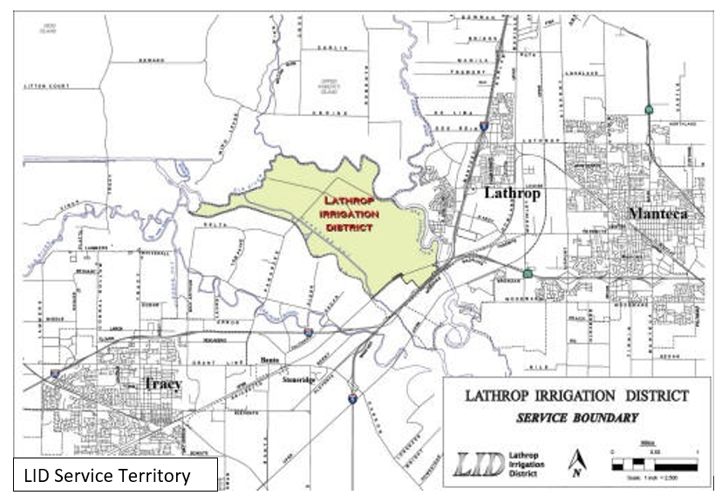

r
Hood

LID does not currently own any generation facilities. Energy is purchased through long term power contracts and market purchases. LID has a tremendous number of roof-top solar customers who participate in our Net Metering and Wholesale Generation Credit solar programs, providing some of the District’s load through excess solar generation.

The service area
LID is the primary electric distribution service provider within an area of approximately 5000-acres in central California. The service area includes the homes and undeveloped lands currently planned for housing known as “River Islands”.

The electric system
LID operates distribution facilities served from the PG&E transmission system. LID supplies power to customers from the 115 kV transmission system serving the local area. The distribution system serving LID customers consists of underground distribution circuits and 5% overhead distribution. The 5% overhead is scheduled to be undergrounded within 5 years.

Goal and objectives
LID was established for the sole purpose of providing safe, reliable and affordable electricity, excellent customer service, community value, innovation and environmental leadership to its customers.
The LID Board will continually review and refine these guidelines to make sure it meets its customer’s energy needs both now and in the future.

A few of LID’s fundamental goals are:
- Safe and reliable energy and environmental protection: Developing and maintaining a sustainable and reliable power supply to meet peak demand growth consistent with state mandates for renewable energy and reduced carbon emissions.
- Customer and community services: Working closely with customers to provide the information, tools and incentives to assist them to more efficiently manage energy use, which will contribute to meeting greenhouse gas (GHG) emission targets and managing peak demand requirements.
- Long term financial stability: Managing price, volumetric and credit risks associated with energy procurement and LID’s finances to meet funding needs and maintain fair and reasonable energy rates.
- Workforce planning & development: Attracting, developing and retaining an inclusive, skilled and engaged workforce that reflects LID’s values and is committed to achieving LID’s mission.
- Operational independence and local control: Retaining local decision-making authority and operational independence.
- Community and Collaboration: Collaborating regionally to attract new businesses and grow existing business to diversify and strengthen the Lathrop economy.
- Long-term infrastructure investment: Build and maintain LID’s infrastructure in a cost-effective manner to ensure sustainable delivery of reliable energy and address economic and environmental concerns.
- Risk management: Maintain an ERM program designed to act as an early warning system to monitor changes in, and the emergence of, risks that could impact LID’s business objectives.

Overview of preventive strategies and programs

This WMP addresses the preventive strategies and programs adopted by LID to minimize the risk of its electrical lines and equipment causing a wildfire. The strategies and programs included in the WMP are evolving and are subject to change. As new technologies, practices and networks develop, and other environmental influences or risks are identified, changes to address them may be incorporated into future iterations of the WMP which is, in effect, a living document.

This WMP integrates and interfaces with various operating policies and asset management and engineering principles which are themselves subject to change. As appropriate, the current version of documents are incorporated either as appendices to this WMP or by reference.
Table 2 is a summary of LID’s programs and activities that support wildfire prevention and mitigation.

Table 2. Mitigation programs/activities

Design and construction
Ester-based insulating fluid (Environtemp FR35) in transformers
Increase overhead wire spacing to reduce wire to wire contact
Pole loading and placement
Transmission line rating remediation
Pole replacement and reinforcement
Wildfire resiliency design
Construction fire prevention program
Substation perimeter fencing
Inspection and maintenance
Transmission line ground patrols
Transmission line splice assessment program
Transmission and distribution wood pole intrusive inspections
Transmission and distribution vegetation right-of-way maintenance
Transmission and distribution annual pole clearing program
Distribution detailed line inspections
Distribution line patrols
Visual inspections of distribution substations
Inspection and maintenance programs for T&D lines and substations
Drive by of overhead distribution facilities and equipment
Detailed inspection of T&D facilities and equipment
Supplemental inspections of high fire risk areas
On-ground routine inspection

Operational practices
Disabling reclosing during fire season
Transmission and distribution system vegetation management
Special work procedure for red flag warning (RFW)
De-energization notifications
Emergency Operations Planning: fire prevention plan
Hotworks procedures
Work procedures and training for persons working in locations and conditions of elevated fire risks
Safety and physical security protection teams
Existing relationship with local government and fire safe councils
Transmission encroachment program
Provide liaison to county office of emergency services’ (OES) during fire event
Leverage existing relationship with local government and fire departments
Targeted communications plan
Active environmental safety monitoring
LID’s Emergency Operations Center partners with local emergency responders for coordination prior to and during an emergency
High fire threat district vegetation management inspection strategy
Inspecting trees with potential strike path to power lines
Expanded pole clearing
Expanded clearance distances at time of maintenance
Patrol and pruning, quality assurance
Increased vegetation clearance

Situational/conditional awareness
Coordinate and collaborate with Fire Safe Councils and County Office of Emergency Services throughout the year to prepare for RFW and high fire risk events
Contractor safety training and orientation for transmission and distribution vegetation management work
Response and recovery
Planned de-energization during fire season
Critical event communications process and procedures
Strategy for minimizing public safety risk
Emergency response plan
Field operations recovery procedures
California Independent System Operation (CAISO) coordination

Risk analysis and risk drivers
LID uses its ERM framework to identify and assess enterprise level risks. LID’s ERM framework takes into consideration both quantitative and qualitative factors to determine the level of inherent and residual levels of a particular risk. An inherent risk level refers to the risk before any mitigations or controls are in place while the residual risk level refers to the risk after all mitigations and effective controls are considered.

Enterprise risk assessment
The ERM framework has a strong governance structure stemming from LID’s Board of Director’s Strategic planning, which began with the conception and initial construction of the River Islands development. The ERM framework is a 5-step process and is integrated with LID’s internal audit process to check for assurance of proper control implementation. The framework requires continuous communications and consultation throughout the life of the risk. The 5-step ERM process is shown in Figure 2 below. Figure 3 describes the objective of each step.

Figure 2. LID’s enterprise risk management process

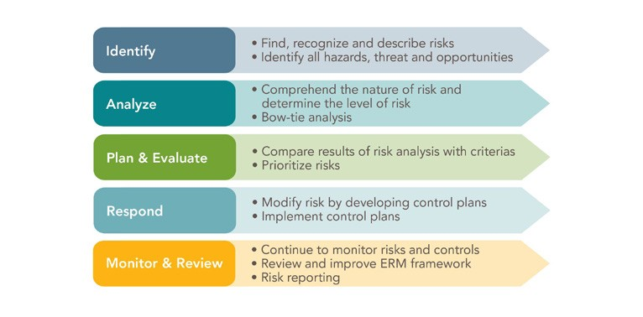
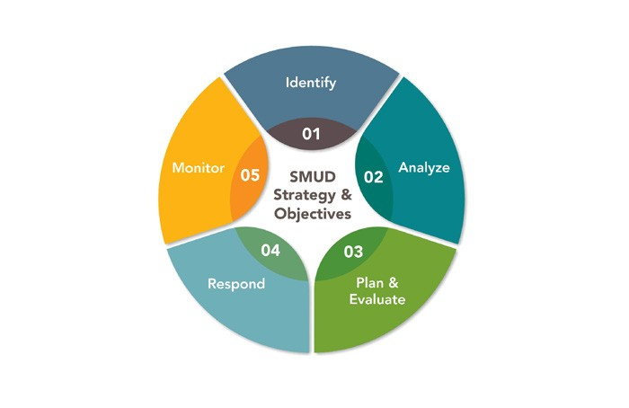

LID’S

Figure 3. ERM 5-step process

Enterprise safety and wildfire risk

LID’s ERM assessment process identified few threats to the LID system, however a bow-tie analysis for wildfires which could potentially involve utility equipment was established for use in future analysis. The SMEs focused on potential causes of powerline sparks that could start a fire. The bow-tie analysis was conducted to identify LID’s vulnerabilities, exposure to and impacts from a wildfire as well as to identify current controls and mitigations to prevent wildfire occurrence, velocity and impact.
Figure 4 provides the risk bow tie, which summarizes the assessment process.

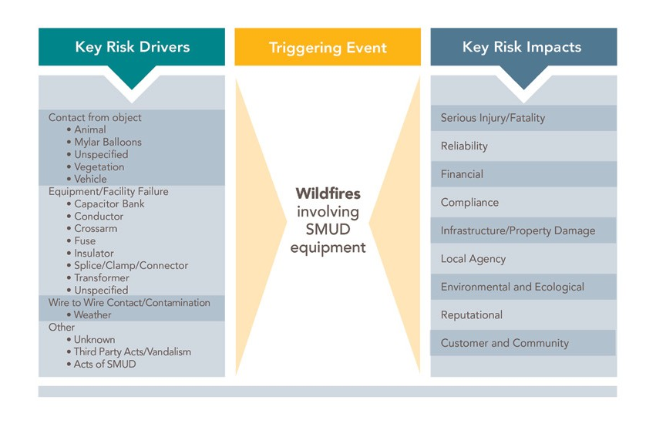
Figure 4. LID’s wildfire risk bow tie. Drivers and impacts are indicators that a risk event could occur, not a reflection of actual or threatened conditions

utility

    - Fire risk drivers
Powerline equipment is generally the same across all utilities; a small niche of manufacturers and suppliers are used to procure equipment for construction of facilities. Slight variances in design and construction may be expected between utilities. LID staff evaluated other utilities’ fire causes and applied its own field experience to determine the potential risk drivers. Four categories were identified as potential for causing powerline sparks and ignitions:
      - Contact from objects
      - Equipment/facility failure
      - Wire-to-wire contact/contamination
      - Other
The following drivers associated with each category. These are discussed below but may not be limited to the following.
      - Contact from objects
Most overhead powerlines throughout the world are installed as bare wire on top of insulated poles and structures. Overhead powerlines are kept at a certain distance from the ground and from adjacent objects, based on the voltage level and applicable design criteria, to prevent contact and faults. However, with thousands of miles of overhead powerlines contacts from objects are anticipated by utilities and can occur throughout the year.

Animals and highly conductive mylar balloons are some of the objects that come into contact with powerlines which can cause sparks and arcs. While protection equipment such as circuit breakers, reclosers and fuses are installed to isolate the faults, there are time delays (within fractions of a second or seconds) associated with when the equipment senses the fault and proceeds to isolate (or “trip”) the faulted section. The time delays are instant
to the human, but not quite fast enough to prevent all sparks prior to tripping. Emitted sparks, molten metal or burnt foreign objects can fall on, and potentially ignite, any fuels underneath or near the powerline.

Vegetation such as trees, branches, palm fronds, etc., from inside and outside of powerline pathways can come into contact with powerlines at any time which can also cause sparks or arcs. Sometimes, the stress of contact is large enough to cause a connector or pole to fail which will lead to wires falling and touching the ground. In some instances, the tree or branch may continue leaning on the powerline and continue sparking or catch on fire due to resulting sparks.

Additionally, vehicles contacting poles or supporting guy wires can damage or break the pole. The heavy, broken pole in turn can put too much stress on connectors or crossarms and cause wires to break and fall to the ground potentially emitting sparks and arcs.

      - Equipment failure
All man-made equipment fails, at some point or another during its life. Failure modes can be discrete (internal) or destructive (materials ejected). Failure components such as hot line clamps, connectors and insulators can result in wire failure and cause the wire to fall to the ground. The energized conductors can emit sparks prior to breaker
or fuse tripping/isolating. Transformers and capacitor banks can have internal shorts that can potentially be destructive and eject materials which could create a spark, leading to a fire.

      - Wire-to-wire contact/contamination
When two or more energized conductors come into contact with each other they will cause sparks and possible material to be ejected. There are many factors that could lead to such an occurrence. Any type of shaking of the pole or high winds may cause the powerlines to sway and touch. A shaking pole can be caused by vehicle contact or livestock rubbing against a pole or supporting guy wires. Certain types of faults (shorts) down the line can cause powerlines to gallop (bounce and buck).
Contamination on insulators can create a path for electricity to flow. This unintended path can track and cause a fault. Typical causes are ash, dust, debris and bird excrement on the insulator. These causes can usually be determined by burn marks along the insulator.

      - Other
LID’s underground facilities traverse through many parts of its service territory which include residential properties, along road rights-of-way (ROW), within business parking lots, etc.
Non-LID equipment and construction projects could be a possible cause of ignition. Even though property owners and contractors take precautions, their equipment can come into contact with powerlines and cause sparking triggering fires in the vicinity. Although unintentional, these contacts may cause damage to powerlines, poles and supporting equipment which may cause sparks and trigger fires in the vicinity.
LID equipment can also be vandalized and damaged, which may cause sparks and fires.
LID takes pride in a properly trained and well-informed workforce. Crews perform switching, construction and maintenance on facilities often as needed. However, the tools and vehicles they use can be sources of sparks or ignition. For example, driving a truck over dry grass/brush can cause the dry grass/brush to ignite. As such, LID trucks are equipped with fire suppression equipment and staff are properly trained to respond to an ignition and in the use of the fire suppression equipment.

Key risk impacts
If one of the risk drivers listed above were to occur, resulting in a fire ignition or wildfire incident, there could be many potential consequences. The worst-case scenarios could include:
- Personal injuries or fatalities to the public, employees and contractors
- Damage to public and/or private property
- Damage and loss of LID owned facilities and assets
- Impacts to reliability and operations
- Damage claims and litigation costs, as well as fines from governing bodies
- Damage to LID’s creditworthiness, or ability to borrow money or purchase insurance
- Environmental and ecological damage
- Damage to LID’s reputation and loss of public confidence
- Customer and community impacts
- Bankruptcy
LID recognizes the impacts that wildfires can have on the company, community and local economy.

LID’s Asset Overview
LID provides electricity to its customers via substations and T&D line assets. Table 3 depicts a high-level description of LID’s T&D assets.

Table 3. Asset description

Asset Classification | Asset Description
Transmission line assets | Assets include conductor, transmission structures and switches operating at or above 69 kV (only 69 kV lines that tied to generation are considered transmission).
Distribution line assets | Assets include overhead conductor, underground cabling transformers, voltage regulators, capacitors, switches, line protective devices and street lighting operating at less than 69 kV (all 69 kV lines not tied to generation are considered distribution).
Substation assets | Assets include major equipment such as power transformers, voltage regulators, capacitors, reactors, protective devices, relays, open-air structures, switchgear and control houses.

Fire threat assessment in LID service territory
    - CPUC high fire threat district (HFTD)

The CPUC’s Fire-Threat Map10, defines a Statewide high fire threat district (HFTD). LID has incorporated the HFTD map into its construction, inspection, maintenance, repair and clearance practices, where applicable. The LID service territory does not fall within the CPUC’s Fire Threat zones.

Figure 5. LID’s territory within CPUC Fire-Threat
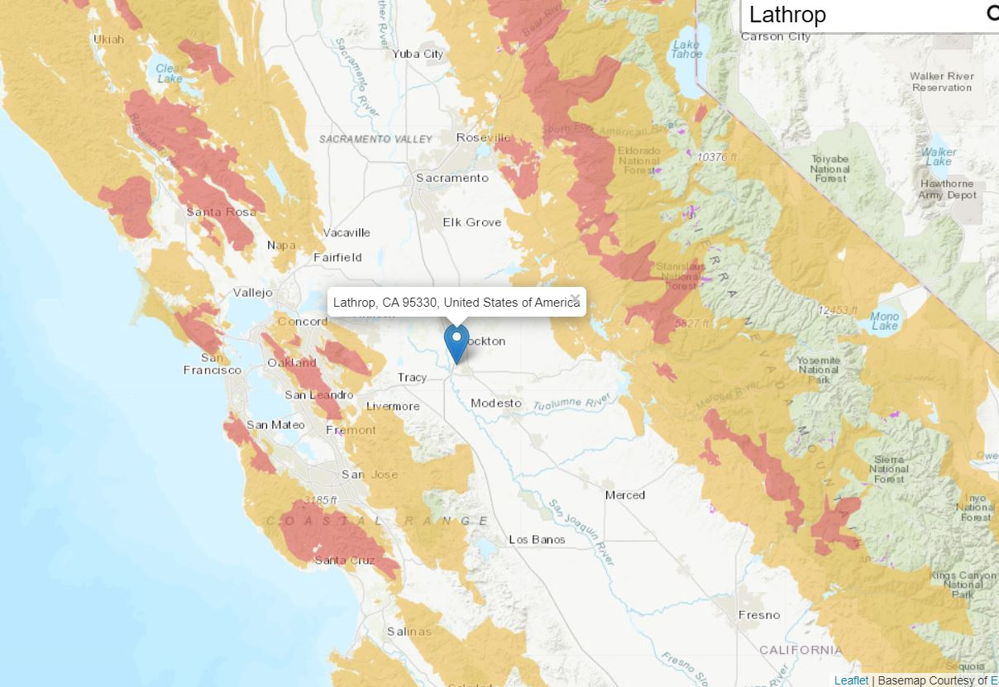The CPUC Fire-Threat map identifies Tier 3, extreme fire risk, Tier 2, elevated fire risk, and areas outside of the HFTD. Figure 5 depicts the CPUC Fire-Threat Map and LID’s location within the map.

LID’s assets are located in areas not deemed within the HFTD (referred to as non-tier or outside HFTD in this document). None of LID’s substations are located within the HFTD.

    - CAL FIRE Fire Resource and Assessment Program (FRAP) California Statewide Fire Map

California law requires CAL FIRE to identify areas in the State based on the severity of the fire hazard that is expected to prevail there.11 These areas or “Fire Hazard Severity Zones” are based on factors such as fuel (material that can burn), slope and the expected chance of burning. “CAL FIRE-FRAP has developed a rating of wildland fire threat based on the combination of potential fire behavior (fuel rank) and expected fire frequency (fire rotation) to create a 4-class index for risk assessment.
Areas that do not support wildland fuels (e.g., open water, agricultural lands, etc.) are omitted from the calculation.
Most large urbanized areas receive a moderate fire threat classification to account for fires carried by ornamental vegetation and flammable structures.”12 This Fire Hazard Severity Zone map considers all ignition risks, not just utility related ignitions.
Although LID takes the CAL FIRE FRAP map Fire Hazard Severity Zones into consideration as part of its wildfire mitigation planning, LID’s Wildfire Mitigation Plan references the CPUC Fire Threat Map which focuses on the risk of utility associated wildfires13.

- Wildfire prevention strategy and programs

LID has measures to address potential wildfire risks. The WMP will incorporate existing efforts and identify the process moving forward to supplement them where a need is identified. LID coordinates with local fire agencies and other first response agencies. It also participates with emergency operations activities in its system areas. It also has an Outage Communications Plan that will be enhanced to address potential de-energization events (LID will include targeted messaging for affected areas that will set expectations and identify support resources).
See the table 5 for activities that address key wildfire risk factors.

Table 5. Activities that address wildfire risk factors

Activity | Risk Factor
Fuel | - Vegetation management  - Fuels reduction
Equipment/ facility failure | - Routine maintenance  - Focused design and construction standards to reduce ignition sources  - Transmission and distribution line detailed inspections and annual patrol  - No reclosing during fire season  - Non-expulsion fuses and arrestors  - Intrusive pole testing and pole replacement  - De-energization of lines during certain conditions
Contact from object(s) | - Animal/Bird guards  - Raptor construction (increased line spacing)  - Increased vegetation clearances
Wire to wire contact | - Monitoring – line patrols
Other | - LID worker/contractor education on fire ignition sources from normal work activities  - Fire watch 30 minutes after work completion in high risk areas

Distribution grid operational practices
    - Disabling reclosing during fire season
LID has adopted procedures for the operation of reclosers. For the purposes of those procedures, fire season is defined as:
- Traditionally recognized as May 1 to October 1, however impacts of climate change and rural growth in areas of high fire danger have extended the season and often the risk is year-round because of potential human-caused fire risk.
- LID Distribution has 99% of undergrounded system which is not affected by wild fires. Of the 1% the75% is high voltage lines with the majority installed on steel poles. The pole lines are monitored monthly, regardless of the season, of any potential fire hazards due to vegetation. The tree growth is also closely monitored and trimmed as necessary. LID takes the position of regardless of the season we take necessary steps to limit any risk of fire.
- RFW in effect for areas inside or immediately surrounding the PCA
LID disables automatic reclosing on certain substation and line reclosers that extend into the PCA. In some cases, the line reclosers are completely bypassed with fuses if automatic reclosing cannot be disabled. On circuits where line reclosers are bypassed, the fuses provide protection to the end of the line. See Figure 8 for graphic of the PCA.

    - Planned de-energization during fire season During fire season and when weather conditions that precede wildfires are forecasted and a wildfire threat is imminent, LID’s Distribution System Operations (DSO) personnel have the authority to de-energize select distribution circuits if deemed necessary. DSO personnel will use individual or multiple de-energization triggers listed below, as well as power system knowledge to make de-energization decisions. This decision requires a balancing of all these factors as well as a knowledge of the area and operation of the power system; no single element is determinative. DSO relies on weather data from various sources, including Wunderground.com and LID’s internal Energy Management System.

Triggers for de-energization of PCA circuits:
- Imminent fire danger
- Customer or community impacts
- RFW in effect for areas inside or immediately surrounding the PCA
- Critically dry vegetation that could serve as fuel for a wildfire
- Low humidity levels
- Temperatures over 100ºF
- Winds projected beyond 12kV design criteria (56 mph)
- Mandatory fire orders in effect (as directed by any Agency Incident Commander)
- On-the-ground, real-time observation from LID or other agency field staff
LID’s personnel have the authority to de-energize portions of the distribution grid during emergency conditions when requested by local police or local fire officials. These are handled individually, and don’t fall under SB901 requirements.

Transmission grid operational practices
      - Disabling reclosing
All transmission auto reclosers are disabled and will remain disabled to mitigate wildfire risks.

    - Planned de-energization during fire season Qualified LID personnel have the authority to de-energize portions or all of the Transmission / Distribution line(s) for safety, reliability, conditions beyond design criteria, threat of wildfires and during emergency conditions when requested by local law enforcement or fire officials.
During active fire season as declared by CAL FIRE, qualified personnel are authorized to de-energize portions or all LID transmission line(s) when there is imminent fire danger, mandatory fire orders are in effect, and/or the transmission system is experiencing conditions beyond design criteria. Personnel will take a combination of many factors into consideration when implementing de-energization procedures, which include the triggers listed below, as well as power system knowledge. De-energization decisions require a balancing of all these factors as well as a knowledge of the area and operation of the power system; no single element is determinative.
- Extreme fire danger threat levels, as classified by the National Fire Danger Rating System
- RFW declaration by the National Weather Service
- Low humidity levels lower than what is required for a RFW
- Sustained winds exceeding design standards
- Site-specific conditions such as temperature, terrain and local climate
- Critically dry vegetation that could serve as fuel for a wildfire
- On-the-ground, real-time observation from LID or other agency field staff

Personnel utilize various operational and situational awareness tools to determine when de-energization is appropriate. The tools are listed below:
- Weather data; such as wind speed, wind direction, air temperature, barometric pressure, relative humidity
- US Forest Service – Wildland Fire Assessment System, https://www.wfas.net/
- CAL FIRE Incidents Information, http://cdfdata.fire. ca.gov/incidents/incidentsstatsevents
- CAL FIRE California Statewide Fire Map, http://www. fire.ca.gov/general/firemaps
- National Weather Service, https://www.weather.gov/
- Inci Watch real time operational tool
- Geographic Information System (GIS) based tools

The question has been posed by the WSAB as to the response by LID in the event that PG&E implements a wildfire safety PSPS event. LID receives the grid-supplied power at the transmission level to the LID infrastructure. In order for PG&E to disrupt power to LID it would necessitate shutting down the entire transmission line, in which case there would be an eminent threat to all surrounding communities of catastrophic proportion, in which case LID would likely not want to energize the system (nor would it be allowed to in accordance with the PG&E intertie requirements). LID does not currently own any self-generation facilities. As growth and financial ability permits LID is looking at a potential support and back-up solutions, but this would also require isolation equipment to detach from the PG&E system in the event of a catastrophic event such as would need to be the case in order for LID to be affected by a PG&E PSPS.

Infrastructure inspections and maintenance
LID performs a multitude of time-based inspections on its T&D facilities. A description of the inspections is summarized in the following sections.
    - Transmission line inspections
LID’s transmission lines are routinely inspected using human visual inspections as follows:

      - Ground patrols
Line inspectors use a combination of walking and driving when conducting ground patrols. They visit transmission tower sites to make detailed visual inspections and on occasion they complete IR inspections. The line inspectors utilize binoculars to detect any damage to above ground components. Line inspectors may climb towers identified with severe corrosion or deformation to determine the corrective action required. Ground patrols are performed annually on all lines.

      - Wood pole intrusive inspections
Intrusive inspections require sample material be taken for analysis, and/or using more sophisticated diagnostic tools beyond visual inspections or instrument reading. Wood poles are subjected to an intrusive inspection to determine and identify problems such as rot and decay. The inspection is performed using a calibrated drill bit that records the resistance and pressure required to drill a fixed diameter hole to a measured depth. The results are produced as a graph on a depth scale which is used to find voids and decay within the pole. Existing poles have been installed within the past five years. LID will intrusively inspect wood poles at a minimum cycle of 10 years and a maximum cycle of 14 years.
      - Vegetation right-of-way maintenance
Both line inspectors and VM planners visually inspect the T&D ROW for encroachments, access road conditions and safety hazards. The VM ROW maintenance program’s approach is to clear the ROW of incompatible species and to maintain low-growing diverse plant communities that are compatible with electrical facilities by using Integrated Vegetation Management (IVM) Wire Zone-Border Zone Management which is the industry standard. This is a long-term approach which supports system reliability through reclaiming the ROW and managing for future workload. This approach allows for ongoing monitoring of vegetation corridors to prevent encroachment into the minimum vegetation clearance distance (MVCD) and also ensures LID facilities meet or exceed state laws and industry standards. 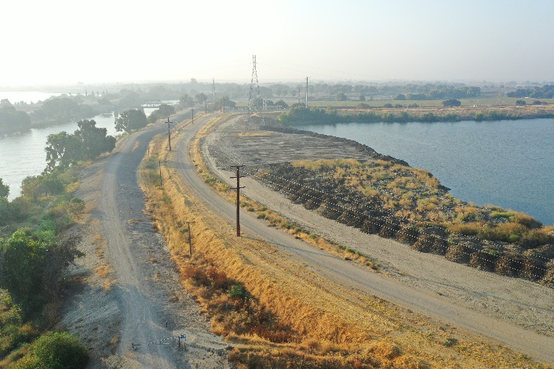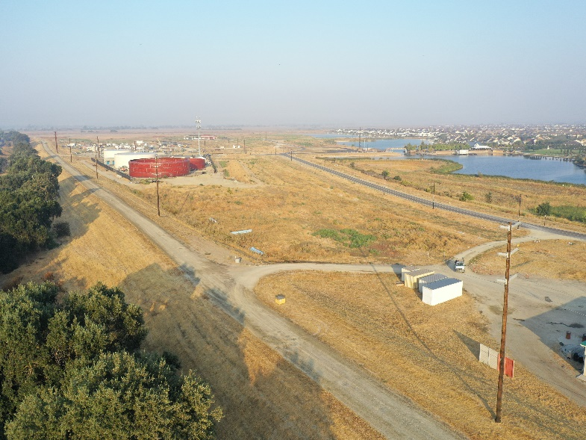

      - Splice assessment program
This program is designed to assess the integrity of transmission conductor splices. The technology used by an outside contractor uses an x-ray machine that encompasses a splice and takes an x-ray image of the
splice. Inspectors then evaluate the image to determine the internal condition of the splice. This allows staff
to identify splices that are potentially close to failure. A special type of in-line splice connector corrector is installed to strengthen the splice when needed.
    - Distribution line inspections
LID performs various inspections on distribution lines to ensure safety, reliability and consistency with standards in California Public Utility Commission (CPUC) General Order (GO) 95, GO 128 and GO 165.
      - Detailed line inspections
Line inspectors use a combination of walking and driving when conducting detailed line inspections (DLIs). They visit each LID pole to make detailed visual inspections. The line inspectors utilize binoculars to detect any damage to above ground components attached to the pole. The inspectors look for broken or loose hardware; mechanical damage to any component; condition of guy wires and anchors; condition of insulators and conductors; condition of disconnects and fuse holders; condition of risers and conduits; condition of transformers, reclosers and cap banks. Ground conductors, moldings, signs, and other minor hardware is also inspected. Similar inspections are performed on pad-mounted equipment and equipment installed below grade in vaults or building basements.
DLIs are performed every five years on all overhead distribution equipment and pad-mounted equipment, and every three years on underground equipment.

      - Line patrols
Line patrollers patrol their designated service area and track their progress with a GIS enabled visualization tool. The use of the tool ensures that all devices within LID’s service territory are patrolled. The patrollers are looking for obvious signs of defects, structural damages, broken hardware, sagging lines and vegetation clearance issues. Any anomalies found are addressed based on severity of the defect. Line patrols are performed annually on all distribution lines and equipment.
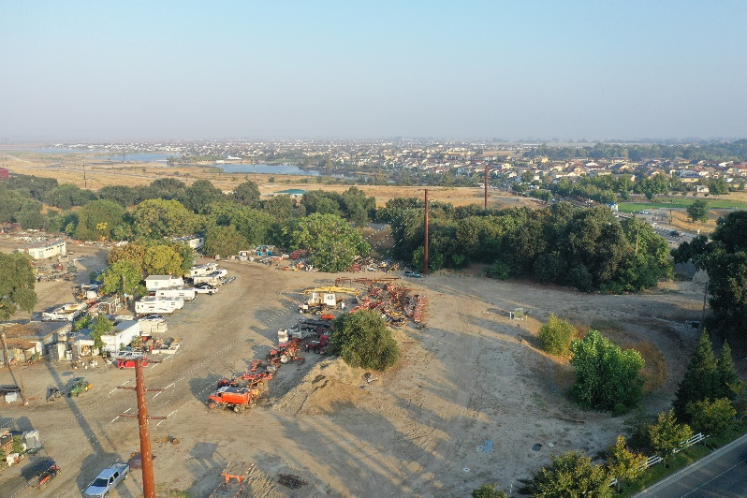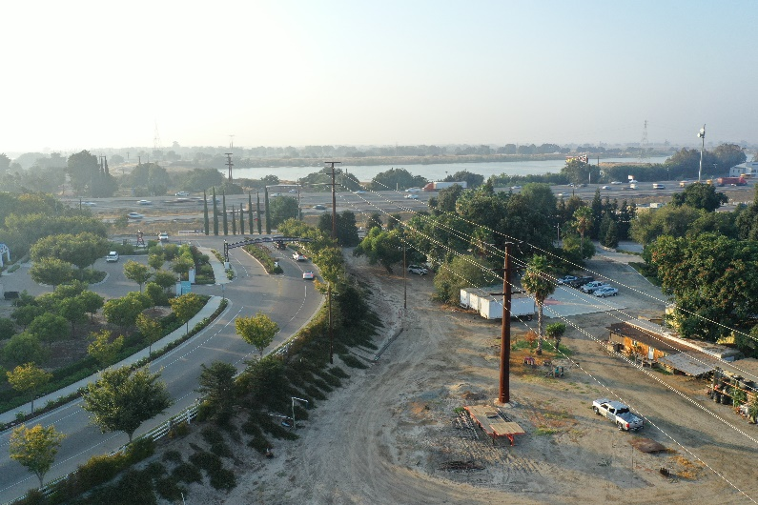
      - Wood pole intrusive inspections
Distribution - wood pole intrusive inspections follow the same criteria as transmission wood poles intrusive inspections.
      - Annual pole clearing program
The pole clearing program is an annual requirement to clear vegetation around poles that have certain CAL FIRE non-exempt equipment on it in the PCA. This program is in compliance with California Public Resource Code 4292. The code calls for clearing vegetation within a 10-foot radius of a pole or tower on which non-exempt equipment is attached, unless such pole or tower meets certain criteria that makes it exempt from the clearance requirements. LID contracts this activity out for completion prior to May 15th of each year.
    - Distribution substation inspections
LID performs various inspections on substations to ensure safety and reliability. LID inspections meet or exceed standards in CPUC GO 174.

      - Visual inspections
Substation inspectors visit each LID substation to visually inspect the facility and all equipment within. The inspectors look for broken or loose hardware; vandalism or damage to any equipment; oil or gas leaks; perimeter fence security; condition of the buss, insulators and other hardware; condition of the control house; conditions of the poles/structures and lines exiting the substation; condition of the disconnects and fuses for signs of damage and connectivity.
Visual inspections are performed 10 times per year.

Vegetation management
LID’s VM program is responsible for the patrol, work plans and quality control (QC) audits of the actual tree work for the T&D system. These activities are performed year-round in order to remain in compliance with applicable Federal Facilities Design, Connections and Maintenance (FAC) 003-4 and State regulations, including Public Resources Codes section 4292 and 4293; and incorporate the standards in CPUC GO 95 Rule 35.
    - Distribution system vegetation management
LID performs routine vegetation maintenance, such as pruning and removal, on a time-based interval. This interval consists of one, two, and three-year ground- based field patrols. The field patrols are ground based inspections of tree and conductor clearances and hazard tree identification. The results of the patrols are targeted areas for vegetation pruning or removal. LID hires contracted tree crews to complete the identified annual vegetation work (pruning and removal) needed to ensure public safety and electric reliability as well as reduce wildfire risk in LID’s service territory.

During the tree work, the contractor aims to achieve up to 12 feet of clearance, unless otherwise directed by LID VM staff. The contractor also clears vegetation from LID’s secondary voltage, service drops and pole climbing space on an as needed basis. LID’s contractors follow American National Standards Institute (ANSI) A300 concepts and utility directional pruning, which supports proper pruning/tree health while achieving and maximizing the pruning cycle.

    - Transmission system vegetation management
LID VM planners perform annual ground-based field patrols to ensure compliance with state and federal regulatory requirements (Public Resource Code 4293) and alignment with standards in CPUC GO 95 Rule 35 and FAC 003-4. The field patrols are ground based inspections of tree and conductor clearances and hazard tree identification.
The results of the patrols are targeted areas for vegetation pruning or removal.

LID hires contracted tree crews to complete the identified annual vegetation work (pruning and removal) needed to ensure public safety and electric reliability as well as reduce wildfire risk in LID’s service territory.
During the tree work, the contractor follows the planner’s prescription to achieve the desired clearance. LID’s contractors follow ANSI A300 concepts and utility directional pruning, which supports proper pruning/tree health while achieving and maximizing the pruning cycle. Additionally, LID’s transmission VM program aligns with ANSI A300 Part 7 IVM standard.

Fire mitigation construction
    - Ester-based insulating fluid (Envirotemp FR314) in transformers
Envirotemp FR3 fluid is a natural ester derived from renewable vegetable oils – providing improved fire safety, transformer life/load ability and environmental benefits that are superior to mineral oil and unsurpassed by any other dielectric coolant. LID began purchasing and installing pad mounted and pole mounted transformers with FR3 fluid. All new distribution transformers installed contain FR3 fluid. This includes replacements for old transformers and new installations.

System enhancement capital projects
LID forecasts and plans for upcoming work several years in advance. This planning process allows adequate level of staffing and funding for needed projects. This section identifies the specific upcoming projects that help reduce LID’s wildfire risk.

Emerging technologies
LID recognizes that numerous emerging technologies are developing and may play a role in building the resiliency of the system. LID will continue to monitor available technologies in future WMPs.

Workforce training
LID has work rules and complementary training programs for its workforce to help reduce the likelihood of the ignition of wildfires.

- Response guidelines

  - Emergency preparedness and response
As a publicly owned utility, LID has planning, communication and coordination obligations pursuant to the California OES Standardized Emergency Management System (SEMS) Regulations, adopted in accordance with Government Code section 8607. The SEMS Regulations specify roles, responsibilities and structures of communications at five different levels: field response, local government, operational area, regional and state (see figure 7). Pursuant to this structure, LID regularly coordinates and communicates with the relevant safety agencies as well as other relevant local and state agencies, as a peer partner.
LID interacts with our emergency response agencies on a peer-to-peer relationship as LID’s version of OES. As part of our response to a storm, fire, rotating outage, black start events, etc., we collaborate with the local OES and provide an agency representative (liaison) to the county (and/or city) Emergency Operations Centers (EOC) to ensure good communication and coordination. Our two primary coordination points are San Joaquin County OES and the City of Lathrop.
For typical winter storms and emergency events, LID Emergency Preparedness staff contact the local OES and establish themselves as the duty officer for coordination. They also invite them to send agency representatives into LID’s EOC. These representatives can include: City of Lathrop, Lathrop/Mateca Fire Chief, San Joaquin County Office of Emergency Services, the National Weather Service and other local critical infrastructure agencies, ensuring coordination for our service territory.
LID has employees who serve as utility representatives when needed at the State Operations Center for the California Utilities Emergency Association (CUEA), which provides a direct link for critical infrastructure coordination to the California State Operations Center.

The question has been posed by the WSAB as to the response by LID in the event that PG&E implements a wildfire safety PSPS event. LID receives the grid-supplied power at the transmission level to the LID infrastructure. In order for PG&E to disrupt power to LID it would necessitate shutting down the entire transmission line, in which case there would be an eminent threat to all surrounding communities of catastrophic proportion, in which case LID would likely not want to energize the system (nor would it be allowed to in accordance with the PG&E intertie requirements). LID does not currently own any self-generation facilities. As growth and financial ability permits LID is looking at a potential support and back-up solutions, but this would also require isolation equipment to detach from the PG&E system in the event of a catastrophic event such as would need to be the case in order for LID to be affected by a PG&E PSPS.

  - Public and agency communications for a potential wildfire
Public safety is a guiding principle at LID. Shutting off power may be the safest approach and makes sense if the risk of a wildfire starting and spreading is severe. While LID’s WMP activities are designed to mitigate wildfire danger, in instances of high fire threat conditions, one mitigation measure could result in an interruption of electrical service. LID proactively communicates to customers and key stakeholders through multiple channels about preparing for potential curtailments, and the power restoration process. LID recognizes that many entities and individuals are particularly vulnerable during extended power outages and makes every effort to provide up to date information to these populations prior to, during and after an event.
This proactive communication is utilized for:
- A wildfire threat to localized circuits within the LID service territory that results in localized de- energization.
- A wildfire threat to LID’s feed from PG&E’s transmission system that results in a de-energization event causing a capacity/energy shortage (rotating outages).
- A wildfire threat to a major shared transmission line(s) that impacts the statewide grid or parts of it and creates a resource shortage for the utilities, including LID, that rely on the resources the line(s) provides.
LID’s Contact Center, Strategic Account Advisors, Media Services, social media and website will provide ongoing and available resources for communication and education for the overall customer base. Additionally, LID launched a webpage, www.lathropirrigation.com , that provides information about LID’s effort on wildfire planning and prevention, how to identify fire risk in areas where LID maintains electric facilities, emergency planning and preparation and LID’s de-energization protocols.
LID also proactively communicates before potential emergency events about our efforts to prepare for and reduce wildfire risk.
In advance of peak fire season, LID will conduct ongoing education communication about how to prepare for emergencies in the event of a wildfire, natural disaster or major outage.
LID’s Public Information Specialists will provide ongoing mass media communication via traditional news media channels and via Facebook and Twitter to provide customers and the community with information about an emergency or potential emergency. LID will use established standard outbound communications channels for unplanned outages.

LID’s Government Affairs Representatives will reach out to the executive staff of state and local governments, elected officials, LID’s state delegation, federal representatives and appropriate agency staff to provide initial contact and ongoing communications by email and phone with messages for their constituents.

Customers will be directed to the www.lathropirrigation.com webpage for information where they’ll be able to find:
- Emergency preparedness tips guide
- Links to additional resources

In the time leading up to a potential or imminent safety shutoff, LID does its best to establish or maintain contact with customers it believes may be impacted (via the various channels mentioned above) and keep the media, local agencies and the public aware of the number of customers affected and LID’s activities and restoration efforts.
Key stakeholders, federal, state and local elected officials, City and County executive staff and first responders are also contacted via a variety of channels and personnel.

LID has specific personnel assigned to elected officials and agencies, and to critical customers including water and telecommunications utilities, potentially affected by a shutoff.

    - Event communications
The potential for de-energization of power to LID customers is extremely remote, however, in the unlikely event that LID is required to shut power off, LID’s goal is to provide as much advance notice as possible. LID will communicate with customers and key stakeholders in advance of an event, whenever possible. LID will make every effort to communicate directly and indirectly to all impacted customers but timelines may vary depending on severity and urgency of the circumstances.

Whenever possible, LID will provide potentially impacted customers with notice before implementing any de-energization action, using all available channels to reach customers and other stakeholders with outage information. Sudden onset of conditions could impact its ability to provide advanced notice to customers.

The Contact Center IVR (Interactive Voice Response) will have real-time recorded information informing each group of customers that may be impacted before the rotating outages begin. Messages will be customized and updated as needed for each specific event.

Among LID’s vulnerable customers are those enrolled in the Medical Equipment Discount Rate program
(MED rate). These customers rely on specialized medical equipment which are certified by a qualified health professional. A qualified health professional certifies the equipment in use at the home is essential to keep these customers healthy. Currently, LID has approximately one (1) customer who relies on specialized medical equipment and who are enrolled in the MED rate program. LID will send these customers an email or letter each year to remind them of the risk of wildfire danger, to have an emergency back-up plan if an outage occurs and refer them to the website for more information.

    - Government agencies and essential service providers
De-energization is a last resort to maintain public and customer safety during extreme fire risk conditions. If extreme fire danger resulted in de-energization or planned rotating outages, LID will provide proactive communications to alert key stakeholders and essential and critical customers like governments, agencies, utilities, healthcare and communications accounts to provide as much notice as possible to minimize the impact on our customers and community.

The following customer categories are considered essential and/or critical service providers:
- Jurisdictions and functional agencies providing essential fire, police and prison services
- Government agencies essential to national defense
- Hospitals, assisted living, and skilled nursing facilities
- Communication utilities, as they relate to public health, welfare, and security, including telephone utilities
- Radio and television broadcasting stations used for broadcasting emergency messages, instruction, and other public information related to the electric curtailment emergency
- Water and sewage treatment utilities identified as necessary for services such as firefighting

LID interacts regularly with executive staff of local governments and agencies, local elected officials, its state delegation, its federal representatives and key critical facilities customers to keep them updated on its wildfire mitigation efforts. LID also works closely with staff members in various departments of regional and local governments, functional agencies, public utilities, nonprofits and other service providers on collaborative strategies and partnership opportunities.
Examples of LID’s communication and engagement with elected officials, government agencies and commercial customers include:
- Regular in-person briefings with federal, state, and local elected officials and key staff on wildfire risk mitigation and other utility-related issues
- Meetings with regional and local government staff and elected officials focused on individual districts, communities, and neighborhoods and mitigation opportunities
- Regular in-person and/or digital communication with critical facilities and key customers through LID Strategic Account Advisors
- Interagency projects, collaborative staff training efforts, and regular communication with first responders and essential service providers
- Cross-LID participation with the San Joaquin County Wildfire Mitigation Stakeholder Group and other government, public and community meetings
- Ongoing communication, collaboration and support for local Fire Safe Councils and other fire prevention agencies and nonprofits

- Restoration of service

If a transmission or distribution line has been de- energized in anticipation of a wildfire threat, LID troubleshooters or patrollers must perform additional steps prior to re-energization. In an event of a wildfire where distribution poles or transmission structures were burned, additional steps must be taken to rebuild the lines.
Steps to restoration of service
- LID work crews must take several important steps prior to restoring electrical service after a de-energization event.
- Patrol. LID crews patrol the line to look for vegetation in lines and any obvious damage that may prevent safe energization. Depending on the length of the lines, and number of circuits, the patrols can take a several hours to days to complete.
- Repair. During patrol, crews look for potential damage to the lines and poles. Where equipment damage is found, additional crews are dispatched with new materials to repair or replace damaged equipment. In some cases, VM crews may be called in to help clear an area of downed trees or branches that have fallen into the power lines while it was de-energized.
- Test. Once the lines and poles are safe to operate, crews test the infrastructure by closing the fuse, or breaker to re-energize the line segment.
- Restore. Power is restored and the outage communication system provides notification of power restoration to customers.

Reconstruction after a wildfire
When infrastructure is damaged during a wildfire event, a lot of work is required to plan and execute the rebuilding effort. After local police and fire officials have given LID clearance, LID work crews can proceed with the assessment and rebuilding effort.
Assessment LID crews must patrol each line segment to determine the extent of damage that has occurred. The patrol involves assessing equipment damage, access issues, any cleanup/ debris removal issues and determining personal protective equipment requirements for the crews. LID works with the local agency in charge of the fire to access impacted areas as soon as the area is deemed safe by fire officials. During this phase the VM team assesses vegetation damaged by the wildfire that could impact LID’s facilities.
Planning After the initial assessment, LID supervisors, managers and engineers meet to plan the restoration. The team will work with system operations to prioritize the restoration efforts, targeting the circuits that serve the most critical infrastructure needs.
Mobilize Based on the size and complexity of the rebuild/restoration efforts, LID will coordinate the crews and material needs internally if possible. Mutual aid and contractors may be used on an “as needed” basis to provide additional support. VM crews will begin clearing the ROW and any dangerous trees that pose a threat to the restoration crews. LID maintains a critical material vendor list and has contracts it can draw on for labor and material needs; though in an instance of widespread catastrophic damage, necessary materials and labor could experience shortages that may delay work.
Rebuild The rebuild effort lead by LID will commence as soon as areas become safe and accessible. The lines will be rebuilt with a mix of temporary and/or permanent structures as determined during planning. The initial efforts will be to get the lines up and restore the damaged circuits. Depending on the extent of damage, demolition may be performed concurrently or after crews start installing new facilities. LID will incorporate new materials and technologies as indicated and available.
Restore LID, mutual aid, or contract crews will restore electric services to our customers as soon as possible after the wildfire. Depending on the extent of damages, customers may have to perform repairs on their facilities and pass inspections by local agencies prior to having full electric service restored. These are coordinated on an as needed basis.

- Performance metrics and monitoring

This section identifies LID’s management responsibilities for overseeing this WMP and includes the operating departments and teams responsible for carrying out the various activities described in the previous chapters. This section also identifies the metrics which are used to demonstrate compliance with this WMP.
  - Accountability of the plan
LID’s Public Agency Liaison Officer has overall responsibility for the WMP

Table 6 lists the responsibility for the departments or workgroups that are accountable for the various components of LID’s WMP. In each case the Public Agency Liaison will be responsible for the accuracy of, and for operations in accordance with, the specified component of the plan.

Table 6. Accountability for the WMP components.

Mitigation Activities | Responsible Department and Workgroup
Risk analysis | Treasury & Risk Management
Fire threat assessment in service territory | Distribution Operations & Maintenance
Wildfire prevention strategy and programs
- Disable reclosers  - Planned de-energizations | Grid Operations (Transmission);  Distribution Operations & Maintenance
- T&D line patrols  - Aerial patrols  - 115kV & Transmission line IR inspections  - Wood pole intrusive inspection  - Splice assessment  - Detailed line inspections | Line Assets
- Substation visual inspections | Substation Assets
- Vegetation management  - Pole clearing program | Line Assets
Fire mitigation construction
- FR3 fluid  - Non-expulsion equipment | Distribution Operations & Maintenance
- Weather stations | Grid Operations (Transmission);  Distribution Operations & Maintenance

  - Metrics
This section provides the metrics used to measure the performance of the WMP and outlined programs.
    - Metrics and assumptions for measuring WMP performance
LID will track metrics to measure the performance of this WMP, and its effectiveness in prevention of wildfires. As industry risk metric standards continue to develop, LID will identify additional metrics to measure the reduction of wildfire risk in future plans. In the initial years, LID anticipates that there will be relatively limited data gathered through these metrics. However, as the data collection history becomes more robust, LID will be able to identify areas of its operations that are disproportionately impacted. LID will then evaluate potential improvements in future updates to this WMP.

PUC section 8387 subsection b(2)(E) requires a discussion of how the application of previously identified metrics
to previous WMP performances has informed the WMP. This discussion is not applicable to this initial WMP. LID expects to include discussion on this issue in its next WMP update.

  - Maintenance performance targets
This section lists metrics used to evaluate LID’s inspection and maintenance programs (see table 8).
    - Maintenance program targets
Work is identified in annual work plans authorized on an executive level, and work that remains incomplete will be flagged in future work plans. Work may be field verified and open work notifications are regularly reviewed to allow management to prioritize work in accordance with current risks. LID’s target is always to complete 100 percent of the work within the initially scheduled time frame; however, emergencies or other unforeseen contingencies can occur that requires material and labor resources to be otherwise assigned. In this instance delayed work will be prioritized in following time periods. All work is completed within time periods to allow for the safe and reliable operation of the electric system in accordance with applicable requirements and industry standards.

Table 7. Metrics

Specific metric | Indicator | Measure of effectiveness | Bounds
Wire down events caused by LID equipment failure | Count of events | No material increase | Fire season  (May 1 thru October 31)
Ignition events | Count of events | No material increase

Table 8. Programmatic targets

Program | Target | Description
Distribution Line Inspections | ≥95% | Perform all detailed line inspections within the compliance period set in General Order (GO) 95/165 by the end of the year. The inspections must be completed within the specified time intervals set for each inspection type. See section 6.4.1 for a detailed description of the program.
Distribution Wood Pole Intrusive Tests | ≥95% | Perform all wood pole intrusive tests scheduled for the year. LID’s goal is to perform wood pole tests within 10 years of installation, and 10 years thereafter. LID is on its fourth year of a re-baseline program to get all poles on the 10- year schedule. See section 6.3.2 for a detailed description of the program.
Distribution Annual Line Patrol | ≥95% | Perform all annual distribution line patrols within the compliance period set in GO 95/165. See section 6.4.2 for a detailed description of the program.
Annual Pole Clearing Program | ≥95% | Complete all vegetation clearing activities within the Pole Clearing Area (PCA) prior to the beginning of fire season of each year. See section 6.3.2.5 for a detailed description of the program.
Transmission Structure Patrols | ≥95% | The goal is to perform all scheduled patrols prior to the end of the year. See section 6.3.1.2 for a detailed description of the program.
Pole Clearing Area | ≥95% | LID will continue to annually manage the PCA to ensure compliance with PRC 4292 to prevent ignition and propagation of fire caused by LID electric overhead assets.
Distribution Vegetation Pruning/ Clearing | ≥95% | LID will continue to annually patrol and complete respective tree work to insure compliance with PRC 4293 to prevent ignition and propagation of fire caused by LID electric overhead assets.
Transmission Vegetation Pruning/ Clearing | ≥95% | LID will continue to annually patrol and complete respective tree work to insure compliance with PRC 4293 and NERC FAC-003-4 to prevent ignition and propagation of fire caused by LID electric overhead assets.

  - Monitoring and auditing of the WMP
The WMP will be reviewed annually. This annual review will align with LID’s existing business planning process. This review will include an assessment of the WMP programs and performance.
LID’s business planning process includes budgeting and strategic planning for a 3-5-year planning horizon.
    - Accountability
LID’s Public Agency Liaison will be responsible for monitoring and auditing the targets specified in the WMP to confirm that the objectives of the WMP are met.
    - Identify deficiencies in the WMP
At any point in time when deficiencies are identified, the Public Agency Liaison or its delegates are responsible for correcting the deficiencies.
    - Written processes and procedures
The operational areas conduct their work according to written processes and procedures. Having written
processes and procedures provide for consistency in the execution of programs and activities.

Monitor and audit the effectiveness of inspections LID has existing quality control processes embedded into its existing general practice. However, for certain programs, there is a formal quality control process. The following depicts a few of these programs.
      - Distribution system inspections
LID’s maintenance planning group manages T&D line and substation assets. A key component in managing assets is the development of comprehensive inspection and maintenance programs. The maintenance planning group develops inspection and maintenance programs driven by the need to ensure the safe operation of T&D line and substation facilities, reduce risk of power-related wildfire, meet federal and state regulatory requirements, achieve reliability performance within mandated limits and optimize capital and operations & maintenance (O&M) investments. In addition, this group regularly monitors inspection and corrective maintenance records, as well
as diagnostic test results to adjust maintenance plans and develop new programs. LID uses best industry practices in developing its maintenance plans.
LID’s inspection and maintenance programs focus on the following objectives:
- Ensure employee and public safety
- Minimize risk of wildfire posed by power lines and equipment
- Maintain regulatory and LID policy compliance
- Improve the availability and reliability of the system
- Employ industry best practices
- Extend the useful life of equipment
- Minimize the total cost of equipment ownership
The maintenance planning group develops and issues annual inspection work plans during the last quarter of the current year for the following year, which are maintained in LID’s Enterprise Asset Management (EAM) system.
LID’s Grid Assets Department is responsible for performing the inspections and corrective maintenance. When deficiencies in LID facilities are identified, corrective maintenance notifications are created in SAP. The priority for corrective maintenance is to remove safety hazards immediately and repair deficiencies according to the type of deficiency, severity and HFTD tiers. Inspection notifications are monitored throughout the year to ensure timely completion via regular internal reports using SAP data. Enterprise applications are used to deploy, visualize and validate work based on business rules. These applications provide the visibility and monitoring of work required to make informed decisions and to achieve compliance with our inspection and maintenance programs.
      - Vegetation management (VM)
LID’s vegetation clearing/pruning activities are performed by contractors. The contractors are quality audited by LID (VM) personnel. Distribution system related work and contractors are field audited and approximately 100% of the tree work (pruning and removal) is reviewed. This quality assurance (QA) effort is tracked to monitor program effectiveness and overall tree work performance. For transmission, LID VM staff perform a quality control (QC) audit of 100% of the transmission system related work performed by the contractor. For both T&D QA efforts all deficiencies are reissued to the contractor management team and corrective action is required.
    - Internal audit
LID’s internal audit department, known as Audit and Quality Services (AQS) provides independent, objective assurance and consulting services to the Board of Directors and management designed to add value and improve LID’s operations. The AQS mission is to enhance and protect organizational value by providing risk-based and objective assurance advice and insight. The work of AQS provides reasonable assurance regarding the achievement of objectives in the following areas:
- Adherence to plans, policies and procedures
- Compliance with applicable laws and regulations
- Effectiveness and application of administrative and financial controls
- Effectiveness and efficiency of operations
- Reliability of data
- Safeguarding assets
- Accuracy of the SD monitoring reports
As part of AQS’ process to develop its annual audit plan, AQS considers all enterprise risks and performs audits over a selection of processes across electric T&D as well as substation assets.

- Independent evaluation, public comment and board presentation

LID will continue to include stakeholder outreach during the preparation of and amendments to the WMP. Input from local fire agencies and fire safe councils, OES and local government organizations. In addition, LID invites federal, state and local agencies, representatives of utilities, telecommunication providers, and critical care customers to attend stakeholder outreach meetings where information regarding the preparation and contents of the WMP are provided. A draft of the WMP posted on LID’s website, is available for public comment. Interested parties were also invited to comment on the plan at the time it was presented to LID’s Board of Directors in noticed public meetings.

  - Public comment
A draft copy of the WMP was made available to the public for comment prior to and during public meetings.
LID Board and Board Committee meetings are open and accessible to the public. Meeting notices and agendas are posted, at a minimum, 72 hours in advance at the LID office and on LID’s website. LID offers the opportunity for persons interested in wildfire related matters to sign up to receive notifications any time wildfire is being discussed at an upcoming Board or committee meeting at www.lathropirrigation.com.

  - Board presentation
Following the initial presentation of the 2020 WMP to the public at the March 25, 2020 Regular Board meeting, the WMP was published on LID’s website. Pursuant to Section 9.1 of the WMP, the WMP was reviewed for the publication of the 2021 and 2022 WMP’s as little change was necessary as the original WMP was adequate, functional, and relevant. At the urging of the WMP review committee, the entire staff reviewed the WMP for the 2023 update and still, there is little to no change in the document as the conditions, responses, and strategies have not changed and the implementation of the processes and procedures of the WMP have proven to be effective. Subsequent versions of the WMP have been and will continue to be presented to the Board of Directors for review and approval and then published on the LID website.
  - Independent evaluation
LID will identify the best qualified independent evaluator to assess the comprehensiveness of LID’s WMP. LID will contract with a qualified independent evaluator with experience in assessing the safe operation of electrical infrastructure. The independent evaluator’s report will be posted to LID’s website and presented to LID’s Board of Directors at a noticed public meeting.
In response to LID augmenting review by engaging with a certified Independent Evaluator from the OEIS list. Although, LID is willing to comply with all recommendations, we feel that using public funds to have a certified 3rd party evaluator review what our Local Fire Chief/District reviewed and approved is a little over kill for our small suburban area. With the Fire Department here locally and LID ability to communicate any potential risks at any time with Lathrop/Manteca Fire District, LID feels that the chance of a wildfire caused by the utility is slim to none, and we do not see a need to pursue a certified Independent Evaluator at this time. LID will present updated changes to the Lathrop/Manteca Fire District and update our WFMP based on their recommendations.

  - California Wildfire Safety Advisory Board
LID has submitted the WMP and subsequent modifications to the California Wildfire Safety Advisory Board (CWSAB).
The CWSAB has reviewed and provided comments and advisory opinions regarding the content and sufficiency of the WMP. LID will consider comments and opinions received by the CWSAB in future plans. It is appearing that the addition of photographic material to the 2023 WMP will assist the CWSAB in identifying LID as being in a minimal, low risk threat situation due to the location which lies well outside the CPUC’s wildfire threat tiers, and poses little threat due to the majority of the facilities being located underground. In fact, recent notifications by PG&E and other utilities have indicated that in response to their facilities potentially contributing to wildfire hazards, they are in the process of moving many of their facilities to underground, a measure LID already has in its favor for prevention and threat mitigation. Such photos are being added as

The WSAB Advisory Borad want to have comment from LID regarding what steps it is taking when PSPS is initiated by PG&E. Lathrop Irrigation Service area is located in a very low fire risk area. During a PSPS event what happens is the areas that are affected the distribution line are de-energized and the transmission line are kept active. LID power comes directly off of the major transmission line and thus the odds of being “turn-off” are greatly diminished. Keeping in mind that LID is a very small utility with approximately 3600 customers having traditional diesel generators large enough to provide power would not be financially viable. However, LID is current working on a new cleaner energy producing generator that would be capable of suppling 70% of the current LID needs and is projected to come on line in mid-2024. Also being a new community over 80% of our homes already have solar as mandated by the state for all new construction.

- Appendix
This section contains supporting information to the document.

  - Definitions
Distribution System Operations (DSO): LID’s DSO personnel is responsible for directing the safe and reliable operation of LID’s Distribution system while operating within current policies and procedures during normal and emergency situations. Distribution system operators prepare, check and administer the execution of safe and reliable switching procedures. DSO will
monitor and maintain equipment loading levels to prevent damage to equipment. This group is also responsible for updating outage information timely and accurately so that information can be provided to internal and external customers.
Fire Hazard18: “Hazard” is based on the physical conditions that give a likelihood that an area will burn over a 30 to 50-year period without considering modifications such as fuel reduction efforts.
Fire Risk1: “Risk” is the potential damage a fire can due to the area under existing conditions, including any modifications such as defensible space, irrigation and sprinklers and ignition resistant building construction
which can reduce fire risk. Risk considers the susceptibility of what is being protected.
Hardening: Modifications to electric infrastructure to reduce the likelihood of ignition and improve the survivability of electrical assets.
High Fire Threat District (HFTD)19: The HFTD identifies areas of elevated and extreme fire risk related to electric utility facilities. These areas are reflected in a map adopted by the CPUC after an extensive public process. It is a composite of two maps:

- Tier 1 High Hazard Zones (HHZs) on the U.S. Forest Service - CAL FIRE joint map of Tree Mortality HHZs (“Tree Mortality HHZ Map”). Tier 1 HHZs are zones in direct proximity to communities, roads, and utility lines and are a direct threat to public safety.
- Tier 2 and Tier 3 fire-threat areas on the CPUC Fire- Threat Map. Tier 2 fire-threat areas depict areas where there is an elevated risk (including likelihood and potential impacts on people and property) from utility associated wildfires. Tier 3 fire-threat areas depict areas where there is an extreme risk (including likelihood and potential impacts on people and property) from utility associated wildfires.

Pole Clearing Area (PCA): LID defined area where poles with non-exempt equipment have annual vegetation clearing and/or pruning within a 10-foot radius in compliance with PRC 4292 prior to the start of fire season, currently May 1 of each year. The custom-defined PCA boundary includes SRA boundary and adjacent areas with similar vegetation, and portions of a Local Responsibility Area (LRA) in the southern part of Sacramento County.
This boundary area exceeds the current SRA boundary due to similar vegetation and risk of ignition. Overhead electrical facilities crossing into and within the boundary of the PCA fall under special operating conditions and fall under enhanced maintenance programs.
Power System Operations (PSO): LID’s PSO personnel analyze, direct, monitor, control and/or operate LID’s Transmission Systems and associated facilities in a safe, reliable and efficient manner during routine and emergency situations. This position has the responsibility and authority to support and implement real-time actions.

Red Flag Warning (RFW)20: A term used by fire-weather forecasters to call attention to limited weather conditions of particular importance that may result in extreme burning conditions. It is issued when it is an on-going event, or the fire weather forecaster has a high degree
of confidence that Red Flag criteria will occur within 24 hours of issuance. Red Flag criteria occurs whenever a geographical area has been in a dry spell for a week or two, or for a shorter period, if before spring green-up or after fall color, and the National Fire Danger Rating System (NFDRS) is high to extreme and the following forecast weather parameters are forecasted to be met:
- a sustained wind average 15 mph or greater
- relative humidity less than or equal to 25 percent and
- a temperature of greater than 75 degrees F
In some states, dry lightning and unstable air are criteria. A Fire Weather Watch may be issued prior to the RFW.
State Responsibility Area (SRA)1: “The California Board of Forestry and Fire Protection classify areas in which the primary financial responsibility for preventing and suppressing fires is that of the state. California Department of Forestry (CDF) has SRA responsibility for the protection of over 31 million acres of California’s privately-owned wildlands.”
Transmission and Distribution (T&D): At LID, for line maintenance purposes, the transmission system includes 230 kV, 115 kV, and 69 kV lines tied to generation facilities. The distribution system includes 69 kV lines not tied to generation facilities and 21 kV, 12 kV, and 4 kV lines.
Wildfire21: An unplanned, unwanted fire in an area in which development is essentially non-existent, except for roads, railroads, powerlines, and similar transportation facilities and structures, if any, are widely scattered (“wildland”), including unauthorized human-caused fires, escaped wildland fire
use events, escaped prescribed fire projects, and all other wildland fires where the objective is to put the fire out.

  - References
- CPUC Fire Threat Map, ftp://ftp.cpuc.ca.gov/safety/ fire-threat_map/2018/PrintablePDFs/8.5X11inch_PDF/ CPUC_Fire-Threat_Map_final.pdf
- Public Utilities Code, Chapter 6. Wildfire Mitigation [8387], http://leginfo.legislature. ca.gov/faces/codes_displaySection. xhtml?sectionNum=8387&lawCode=PUC
- County Maps of Fire Hazard Severity Zones in SRA, https://frap.fire.ca.gov/frap-projects/fhsz-in-sra- county-maps/
- General Order 9522 contains rules for the design, construction, maintenance, inspection, repair and replacement of overhead utility lines. http://docs. cpuc.ca.gov/PublishedDocs/Published/G000/M209/ K464/209464026.pdf
- General Order 16522, Inspection Requirements for Electric Distribution and Transmission Facilities. http://docs.cpuc.ca.gov/PublishedDocs/Published/ G000/M209/K552/209552704.pdf
- General Order 16622, Standards for Operation, Reliability and Safety During Emergencies and Disasters http://docs.cpuc.ca.gov/PublishedDocs/Published/ G000/M209/K451/209451792.pdf
- General Order 17422, Rules for Electric Utility Substations http://docs.cpuc.ca.gov/PublishedDocs/Published/ G000/M031/K879/31879476.PDF
- Power Line Fire Prevention Field Guide, 2008 ed. (New version being prepared by Cal Fire) https://osfm.fire.ca.gov/media/8482/fppguidepdf126. pdf

  - Acronym glossary
ANSI (American National Standards Institute) AQS (Audit and Quality Services)
CAISO (California Independent System Operation)
CAL FIRE (California Department of Forestry and Fire Protection)
CPUC (California Public Utilities Commission) CUEA (California Utilities Emergency Association) DLI (Detailed Line Inspections)
DSO (Distribution System Operations) EAM (Enterprise Asset Management) ERM (Enterprise Risk Management)
EROC (Enterprise Risk Oversight Committee)
FAC (Facilities Design, Connections and Maintenance) FRAP (Fire Resource and Assessment Program)
GHG (Greenhouse gas)
GIS (Geographic Information System) GO (General Order)
HFTD (High Fire Threat Districts) IR (Infrared)
IVM (Integrated Vegetation Management) KV (Kilovolt)
KWH (Kilowatt Hours)
LIDAR (Light Detection and Ranging) LRA (Local Responsible Area)
MED (Medical Equipment Discount)
MVCD (minimum vegetation clearance distance)

MW (Mega Watts)
NASA (National Aeronautics and Space Administration) O&M (Operations & Maintenance)
EOC (Emergency Operations Centers) OES (Office of Emergency Services’) PCA (Pole Clearing Area)
PG&E (Pacific Gas & Electric) PSO (Power System Operations) PUC (Public Utilities Code)
QA (Quality Assurance) QC (Quality Control) RFW (Red Flag Warning) ROW (rights-of-way)
SB (Senate Bill)
SD (Strategic Direction)
SEMS (Standardized Emergency Management System) SME (Subject Matter Expert)
SRA (State Responsibility Area) T&D (Transmission and Distribution) TTX (Table Top Exercise)
VM (Vegetation Management)
WAPA (Western Area Power Administration) WMP (Wildfire Mitigation Plan)
WUI (Wildland-Urban Interface)

